C)..

.'\:

.,,---:--,
I: First I would like to ask you where and when you were born? R: In Grlinau (Brandenburg).
I: And when where you born?
R: O Gosh, thats a delicate topic.
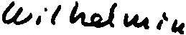I: Of course you don't have to answer this question if you don't feel like it.
R: That's so completely unimportant, I won't exist much lon€J:['.
That is no more a matter of consequence~ 12/26/01.
I: Thia is very surprising to me, I wouldn',1; have read that in your face, you still seem to be so lively.
Could you tell me a little bit about your-family, yuur parents and whether you have got any brothers and sisters?
R: My father was a jeweler and a goldsmith and he died in 128.
I: Have you got any brothers and sisters?
R: Yes, my brother was a millionaire, but he is dead. I: was he older or younger than you?
R: Three years younger.
I: And there weren't any more brothers and sisters? R: No.
I: How would you describe your mother?
R: My mother was my mother was my mother. That's all I can say.
I: Whom were you more attaached to, to your mother or to your father? R: To my father, m4tather, but that's logical. All girls are more
attached to their fathers.
I: Could you describe your father a little to me.
R: My father was a wonderful man. He had wanted to study theology and at that time it hadn't been the rule yet that students could study for free and he had a stepmother who said: no, the boy doesn't need to study. So he became a goldsmith and jeweler.
But actually he wanted to study theology. He was the local principal in GrUnau and there he even effected all the weddings, i.e. the civil ones.
I: But let me return to your mother once more .•.
R: My mother died1still very young, I believe I was 6 or 8 years and my brother 5 years old.
I: What did this loss mean to you?
R: I was still a child, today I _can't answer this question anymore
I was much to young.

-/f-

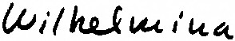

:n ..
I: Who kept the house for you then?
R: We had a stepmother then, but ~ery relationship. She was very strict) up well.

good woman. We had an excell•n·
·very correct and bro"ght us
I: You've told me in the very beginning that you grew up in Sumt at
Biric~~e?4C~. Did you go to school there, too.
R: Yes, at first I went to primary school and then to a hig.her daughters school.
I: Up to what grade?
R: I graduated secondery school. I: What did you do afterwards?
R: I'm a learned orthop~dist and bandagist and for 10 years I
worked at the Wiakler company, Friedrichstr. 133a. For the company I went to hospitals every day. Then I was self-employed for 35 years, had 4 dru~tores. I went for my poison examination by senior assistant master Lasch and I opened my first drugstore at the Stettiner Station. It was Berlin's central station but you don't know that anymore.
I: What happened then?
R: Then I went to Ztilsdorf and aupp Li ed-vthe Brandenburgiscihe Motor Plant with medical products. I made a lot of money there and I still benefit from it.
(J
I: Now I would like to proceed to the then political situation in
Germany.···1'.hat did you think as the Nazis came into power, 1933? R: I went to Ztilsdorf '38, built my house in sumt ,o.a,,-roorn-house
and lived in my house and Zlilsdorf was 7 km away from Sumt. I: To come back to the takeower, what were your feelings?
R: ~didn't think anything at the takeover but what came later.that was bad. We had a very big and distinguished group of friends,
 | very | distinguished jewish people.
I: R: | When  When | did you realize what aims the Nazis had  ,.L;tl  I · was~n the Eichendorfstreet.

concerning the 1 ews?

I: Eichendorfstreet?
R: Yes, at the Stettiner Station. There the plundering took place already. I went to the KurfUrstendamm with a friend and we saw how all this jewisch stores were plundered.
I.' :But the persecution of the jews did start earlier •••
R: Yes, yes I became engaged then, 1934, he was an Anti-Nazi. All the time we drove all our friends from one part of the city to
CJ
an other. We had just learned that they weren't allowed to use
1llwi•jS
the tram anymore. I was~kind of afraid because if we would have

-2-
R: run into a control then both of us would have been arrested. T.'ha.nk God only he was arrested, and he didn't come back again. He was an extraordinary big friend of the Jews.
0
., I: Did your parents have any jewish friends, did you talk about Jews

in your house?
."..,
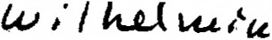R: No, I don't even know whether there were~Jews in Grunau at all.
I: Pleas$, do describe once more the situation of your jewish friends as they asked for help.
R: They gave us a call and said that they were very handicapped and very narrowed now and that we should come. Then we drove from one to the other. I guess I wouldn't do that once again, today, for the reason of my age alone I wouldn't 9ut I guess all this anxie•
ty I went through at that time,I wouldn't dare that anymore, today.
I: so you were quite aware of the big risk you took?
R: Yes, yes, of course. I always said1Lutz, Lutz, what are we going to do, just consider us being caught on the street. Then both of us will be gone.
I: It was merely a question of friends of yours?
R: Yes, we actually couldn't do more for this people, couldn't effect more.
() I: Did you ever recieve anybody at your house?
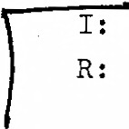R: Yes, Kurt Rosenberg and Rene, the small boy.
Did you talk about Jews at home?
Yes, my mother was relatively anti-semitic. But I must tell you, I met many anti-semites in the Nazi-time who could never make a difference between a Semite and a German. But my mother had a nose for that.Well, we brou~t along some friends, we were allowed to do so on weekends. There was a female half-jew and
she objected to her for instance. She would never have killej anybody therefor, she di.dnlt like that. That was her private attribute. But I kept company with many Jews from my youth and as
.::r was in my school in Berlin, 1924, there were lots of j ewish
girls in my class. There were also some from the gentry of Brandenburg who I didn't know so well, simply because they were much more primitive. Here I visited many jewish houses which
were much more appealing to me because I just was used to culture
and beauty from home.
I: When did you realize what kind of aims the Nazis had concerning the Jews?
R: I read "Mein Kampf". fread the first edition, you know. We should
be aware of one thing, the German was f.:iixst-class, the intelectual content as bad as always, that was Goebbels influence.
-3-

·O..

0

0
R: There a neighbour said, say, did you recieve a jewish child at your place? No, those are from Hamburg, the par-errt scar-e bombed out and now Rene is staying with us: And0~vndaysrll this fol~· came out to us, that really was the star-time. Those who stayed
here, they always thought that there has to be an end to it,soon. It was a horrible time, believe me.
I: can you remember what time that was?
R: rt must have been around 141 or '42, that was the worst time.
I: As far as these people are concerned they were friends of yours.
How would you have reacted when a stranger had ~sked you tor help. Would you have helped him, too?
R: Maybe, yes, I couldn't even really atiswer that since we had so much work with our friends. And every Tuesday we went to the Jewish Hospital in the Iranische StraBe and brought our little bit of butter there. We knew a man in Ztilsdorf who worked at a card•-place and he always gave us some food-cards. So we were able to give to the Jews.
I: Why do y6~·suppo~e this man:in the office did that?

R: He got things from us, too, that was a kind of mutual exchange.

I: You've mentioned the big fear yo.u had in these emrprises •. How would you describe yourself? Do you like to ·be in charge? Have yo\.
got a sound self-confidence? Are you rather a leader? Rather active or passive? Bow were you then?
R: I was a very fearful person, today r'm much more courageous,
today I'm on my own. But I was very fearful. I was a very fearful person. I changed this when I became independent. Then I had no other choice. As my Lutz was arrested the Nazis took away my
work, that was very bad for me. Than I begann to provide Jews
who I had lielped, too, the married couple Klein, they lived here in some small cross street,they had rented my drugstore,.
they were illegal in Berlin, I begann to provide them with provisions and with stuff from my drugstsre, too.
I: Regularily?
R: Regularily. They came here and I was always so afraid when they
entered my shop. For God's sake, Mr. Klein, if you are seen here.
, a.I~~ ,
I: You ve.t.mentioned that your fiance was arrested.
R: He wae arrested in January, 14th, 1943.
I: Why?
R: Because he was an anti-Nazi. And decomposition of the Wehrmacht and something else. Resistance to the Third Reich and accomodati:
-
a~ protectioning of Jew2',
- ;

0..
t'ite. G.c,\g, l'0 "fl'''
R: After Lutz was arrested~entered rny~at will. And then I burnt all
\ I ,
of their house-papers, so that the Gestapo wouldn't find\miea, all of them in the oven. But they didn't come back again. The Gestapo said I should not leave my house, they would be back in a fortnight • But, thank God, they didn't come again. And in July my Lutz came
to stutthof! (KZ). Kurt and Lotte were picked up, too. In the
Gerlachstreet, there all the Jews were lodged, there we still visi•
ted them. They could only come up to the gate and there we ·gave them fruits and other stuf!. It was horrible. And in January, the
14th my Lutz was arrested.

(. :I: (:QIII p1civ1c. t~k.

CJ.

(J
I: Can you tell me some more about the Rosengergs, sol11lu * P J t .a
better pi ctJJre--=cf tb•w .J,o ~o .,.,.yttf+.
R: They were very elegant people. Actually, all of our jewish people w~
very much so. Otherwise 1"night not have'been so fond of them.
l: Did the Rosenbergs ask for your help or did that come from you?
R: That came from us,that's understood. Every Sunday they were at
our place, not all at a time so that they could get something real good to eat.
I: Didn't your neighbours realize what was going on?
R: Well, the Roders were pretty bad. They were thoee who said: Have you got a jewish child at your place. I respond: no, they live in Hamburg and are bombed out. She had to believe that. But no, no again, I believe I couldn't do all of that anymore, today. I just couldn't do it '11"1·'/more. But I've gro,..n old in the meanwhile and let's hope that this will never happen again.
I: Now I would like to a~k you eome rather general questions. How,
for one, do you Bee the world? Is man rather alone and isolated on earth or is he rather to be seen as a social being?
R: No, they all live alone. I can see it now, you know. r'm trying
to find a place in a home and in the home they are all alone, too. People are all alone, more or less. There is no community any more. Not even among the nearest relative~.
I: Do you think this was more the case in the past?

R: Yes, yes.
I: And what do you attribute that to?
R: I can't tell you that, I simply know it.
I: Are the interests of man more directed towards on€sel! or towards

others?
R: Only towards oneself. Look, I still belong to the old sort. I'm stupid, I would 8ay. All my money I've had I gave , Bethel, T~e Deacon Mission, children, the Erna Graft-Foundation, the Red Cross
-b -
ctlft.V
R: ha~ got 15,000. I gave~all my money, all to these social place~.
All after my death. Would you like to take a look at my will? (Here a longer conversation about assets and the heirs begins)
0
I: Do you donate regularily for a good thing, e.g. Bread for the Worl<
·' or similar things?
R: Yes, ~sen~ a lot of meney to children-villages and to Bethel I
send a lot.
I: Do you believe there is a social responsibility to help those who are in need?
R: Why, certainly! I want to help them like I helped together with my Lutz.
I: Did you have the feeling that it was your obligation to help your jewish friends? Even if you: risked your own life with this?
R: But we had to do that, they needed us. And Lutz was such a great
Nazi-hater.
I: What part does religion play in your life? Do you believe in a life after death?
R:

I:
C) R:

I: R: I: R: I: R: I:
Yes, I do absolutely. I'll come again as a dog. I've had dogs all my life. I'll come again as dog.
Do you believe that all people come again in a different shape? I should say, yes, but I'm not a person who goes to church. I don't go to church at all. But I'm a pious person from the inside I should say. I believe but I don't go to any church.
What do~!telieve in?
That's hard for me to say. I believe in God.
~id that play a part as you helped th~ersecuted Jews? No, somehow I just want to help people.
Was there a person in your youth who was a model for you? No, no. •at that I could remember.
Was there later a person who you really admired, except fo~your
friend?
R: No, nobody admired m~ as well.
~-· The help for your j ewish friends was linked to a big risk for yourself and also for your friend. Could you imagine yourself acting the same i! you had had small children whose lives would have also been endangered by that?
R: You know, I really couln't answer that with a good conscience because I don't know it. And my brother·.lived in Frohnau, he was always well off.
0
I: How was the relationship to your brother?
R: My brother is my brother, like my father a good person.

-1-
I: was there ever a moment or a time in your life where you were dependent on others?
R: No!
..
I: That what you have done was surely something completely extra• ordinary in those times and you should be~lwarded therefor. But the people who could have thanked you don't live any more, now.
· How were you rewarded1then?
R: I was rewarded in that, I'm not ungrateful, I've got money. And
I always say: destiny is good to me, I've got no problems.
I: Do you believe that people can determine their tatesby their own. or do you think that everything is predestined?
R: O yes •. I even belirve that everybodyfcan arrange his lite himselt somehow, as:1i is possible. That's my firm conviction.
I: And this also applies to your lite?
R: Exactly! I was self-employed !or 35 year~ just imagine that.
I had to make the best ot it, there was nothing to do about that. IS Doee this also pass \/•""f" sphere not only for your business'
!or I.personal
R: I think so. I think so.
I: Have you ever thought aboutjthe reason why exactly you and your tiance helped those persecuted Jewe while so many others hadn't
0 done anything. Why did you take this risk and not others?
R: First of all we had a very precious group of people and I simply
considered it a matter of course. N~one ever thought that it
would go so quick,that they would be taken away. We thought those people must be helped as long as this was possible. And then one
atter the other was brought to Theresienstadt._~~·was horrible.

/ \
I •.
<.:
I: Did you know other people or groups which tried to help and protect jewish people.
R: No, my Lutz and me, we were actually always !or us. And with our
jewish friends. But, then again, that was much to dangerous, one couldn't talk to others about that at all. We hardly had any connections to other people. Atter they were picked up I called
. -, the office every single day, where they came back from There•
sienstad tor Ausschwitz and every time I got this: no, the - are not registered. Apart from that I've never again cared about
any things. Later I became an 11Unbesungener Held11 and I thought
then, great, now at least you've got this record of honour.
I always took much pride in that. But I never made use of it
'Ulat I had this or so. Never. I was only proud inside, just for me.

- <?-

0
,,

0

u/ \

after all. Now look, we drove from one part of the city to the other with our car, I trembled and shivered. I said to Lutz: When the should get us then both of us will be arrested. Well, I'd always been incredibly afraid. But we have done it after all and one day all was over. That was just so awful, yes.
I: | was it · of importance for you,then1that you | personally
R: | helped your jewish friends or could someone else ~27e that- the main thing was that somebody helped them at No, that was for us a matter of course. That were our | lone all? friends

I: Do you think your personality has been changed by these events?
R: No, I don't believe so. I've always been a person who liked to help and r've always been a person who liked to give. And I've kept that till today.and I'm glad about this, too.
I: Was there anybody in your youth who you were friends with and who showed a similar helping beaviour as you'did?
R: No, no. That came quite from my own. And we really were good
friends. And they were no everyday people but real qualified people. t
I: .Have yo1'!30me personal motto, some kind of guide to which you adjusted your li!e? •
R: No, no ... no.
I: Did it ever happen that somebody asked you for ~elp and you were forced to say that you couldn't?
R: No, no one, no one. We had our group and there we did whatever
was possible and everything else wasn't of interest for us. We were so shoked by this whole matter how things were going on out there, that was awful.
]: Did it ever come to your mind that you yourself or somebody dear could also get in to a situation .where one :J.was dependent on active help by other people?
R: No, this never occured to me. I couldn't even think so !ar, theI
because_ I was so occupied by these people and I lived in a perpetual fear. I said: Lutz,Lutz, when they are going to get us. And there was this neighbour who said that we had a jewish
kid with us. There I said ,no, they lived in Hamburg and were bombed out. We will keep t~~ boy only temporarily~ And then
Rener,nd Lotte Rosenberg came to Theresienstadt, too. That was so awful,then. ·
I: Do you believe that people who only watched all of this and
for some reason didn't help the Jews are bad people, people who are sunnosed t~ be condemned morally?
-'· \ .-. 1 cL..~: .-· :_ •
•

0-·

(J
ff: No, they are superficial. As my view is generally that the GermanE
a~e mentally inert, that has always_been my outlook. Germans
are to lazy to think. That's why so many things can happen which shouldn't. But they are all much to indifferent. Well, and we tool interest.- .. so very strongly because these were our !riends after all.
I: Would it have made a difference to you if a stranger had asked you for help?
R: Mostlikely we wouldn't have got to any complete strangers. our j ewish group of acquaintance .:was much to big. As we took Rene and Kurt to our place it was a big risk. But we did it.
I: How would it have been if you hadn't helped them? How would you have feeled?
R: Well, to our friends I would've felt bad. But to other people
I was exactly the same mentally inert as I saiap-bout others.
 | But to us that wasn't the | question because we actually had so
 | many friends.
I: | was the opinion ot others | important to you? Of peoplee~,"w' hose

judgement you set great store?
R: But nobody knew about that. Only my neighbour who said, you do have jewish company, don't you. I always denied that.
I: You've told me that your friends came to your place for lunch
every sunday?
R: Every sunday, every sunday they ate themselves full at our place. I: Didn't the neighbours get that?
R: well, the houses were tar apart. The Holkers house was placed way ahead at the Liegenwalder Chaussee and my house in the Seering. They didn't get that. They only noticed that we had a jewish child at our place.
I: Now I've got a quite different question. Have you got a favourite
party?
R: No, I'm t:htough·witp.· pol.itics.Ana_t_pe next time I won't go to the polls anymore, l•t me tell you that. So much, so much isn't as it should have to be or should be. And when I think about
all the embezzlements there were, then I'm very disappointed in
deed.
I: Have you ever had a favourite party?
R: No, no! Never, never! I've never cared about politics. And my
Lutz didn't as well.
I:

e: R:
You've told me bet.ore that you believe to come back to earth in a next li!e as a dog. Could you explain that a little to me?
No, I know or I believe that we will all come again.
-An

."- ..:
. ,

()

(_)
R: That's my firm conviction. And I asked myself, as what do you actually want to come back and,you would like to return as a
dog. I've haf dogs throughout my lite, you know. But I've always thought that mit~as been.better ott~~ many~child. That was my contents, yes • And if you return to earth once again, you
would like to return as a dog. The same as it is my firm con•
viction that I'll meet one o! my friends, one of my darest .· · friends on the street again, that is , the double. And then I say to myself, that surely is peculiar, she has been dead for so and so long and here the very same person is liking around.
I: Do you mean your jewish friend Lore Rosenberg with this person? R: No, she looks exactly th1same like my friend Edith whom I
shared my house.·. Sh~ was a half-Jew. And there I thought there
really is something to it when· ·they say that man comes again. Just like my father isil::..t dead. When I've got something serious to talk about then I talk to the picture o! my father
and he must stand by me. Well, that's my belie!. And just con•
sider, he died in~128. That's more than 50 years ago.
~'I: Now, let me ask my last question. If we want there to be more people on earth like you, i. e., peoplef"ho risk their own lives in order to help others, what kind of advice would you give. What, for example, would you advise young people?
0 R: I wouldn't give a young person some ,~·ce of advice to do this
or that. I would just say: follow your own way, that's the only truth there ia on earth. Follow your way straight and don't look to the left or to the right. Don't listen to what other people tell you.
I: Don't you believe that we.as parents have the duty to bring up
our children as responsible people .. who are willing to help others who are •in need?
R: Oh, today nobody is in need anymore. People are so well of!
today, they have got none ••• r had a wonderful down-bed.

--------------------------------------------------------------
The interviewed relates in detail how she wanted to give away the
down-bed and nobody wanted it in the beginning. The end of the interview.

0
'
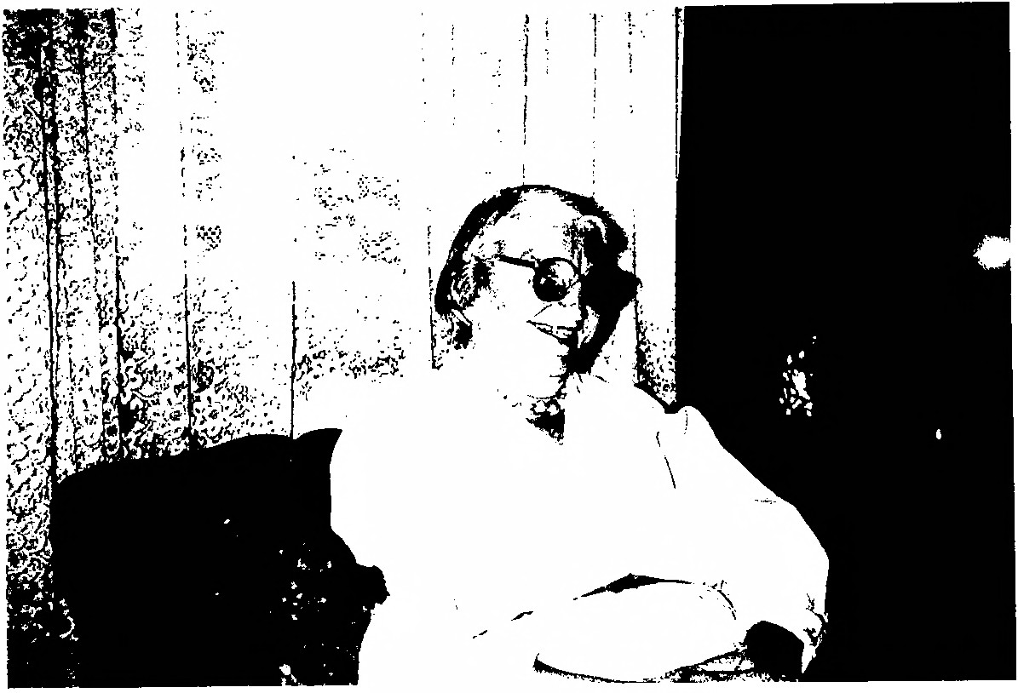I
l l
v~- _....-.. -

-.~... ..--:.:
· ~

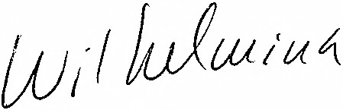0

..

